**ndArray Object Internals :**

* The NumPy ndarray provides a means to interpret a block of homogeneous data

(either contiguous or strided) as a multidimensional array object.

* Part of what makes ndarray flexible is that every array object is a strided view on a block of data
* A pointer to data—that is, a block of data in RAM or in a memory-mapped file
* The data type or dtype, describing fixed-size value cells in the array
* A tuple indicating the array’s shape
* A tuple of strides, integers indicating the number of bytes to “step” in order to advance one element along a dimension

**NumPy dtype Hierarchy :**

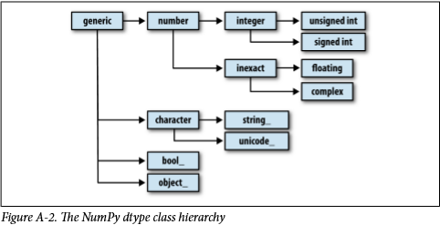

**Advanced Array Manipulation :**

* **Reshaping Arrays :**

You can convert an array from one shape to another without copying any data. To do this, pass a tuple indicating the new shape to the reshape array instance method.

In reshape method we take multiple arguments in which one is the new shape for example :

arr.reshape((2,4)) this highlighted area is the new shape argument in which we are passing two values. First value is for no of rows and second value Is for no of columns

The other argument is order argument let’s see what do we mean by order :

There are two types of orders in which we can reshape our arrays i.e.

1. C order
2. F order
3. **C order**

The items in each row of the array are stored in adjacent memory locations.

By default, NumPy arrays are created in row major order. Therefore if we want our data to be stored in C order, we do not need to mention or pass this argument to reshape method.

Means ke data row wise store hoga :

**Row wise data kese store hoga ?**

**Dekho arr me ek data he 0 to 7 ka ab wo jb data reshape krne lgega tb wo dekhega C order he means mujhe rows fill krni hen, nahi aya smjh ? aese dekho usko pta he ke mjhe rows pe kaam krna he or 4 values honi chahiye us row me so wo pehle 0 se 3 tk row wise data store krega then phir same way me next row fill krega**

**for example :**

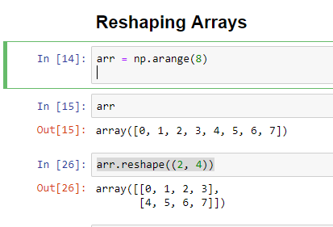

1. **F order**

This is the alternative to row major ordering is column major order, which means that values within each column of data are stored in adjacent memory locations.

Means ke data column wise store hoga :

**Column wise data kese store hoga ?**

**Last time row major me pehle rows fill hoti thin then column ki bari aati thi , ab column major / F order me pehle wo column ko fill krega mtlb usko pta he ke 4 column hen or har column me 2 values hen to sab se pehle wo column fill krega pehla column fill krega or 0,1 fill krega first column me then in second column wo 2,3 fill krega and so on isi trhan fill krta rahega .**

**For example :**

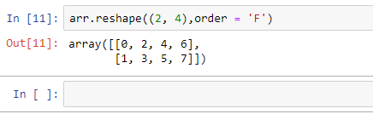

**Concatenating and Splitting Arrays :**

**Concatenation :**

numpy.concatenate takes a sequence (tuple, list, etc.) of arrays and joins them together in order along the input axis:

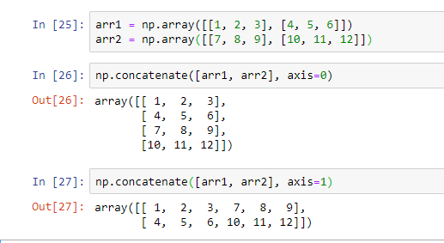

In the above example we can see that there are two different arrays of same dimensions, hence for concatenating, dimensions of all arrays must be same. Also we can see that there are two different values of parameter axis. When we work on axis 0 it concats the arrays vertically, where as when we work on axis 1 it concats the arrays horizontally. There are two more numpy methods to perform the same operations i.e. vstack and hstack.

**For example :**

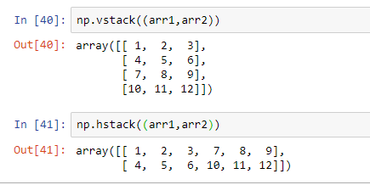

**Spilliting :**

split, on the other hand, slices apart an array into multiple arrays along an axis:

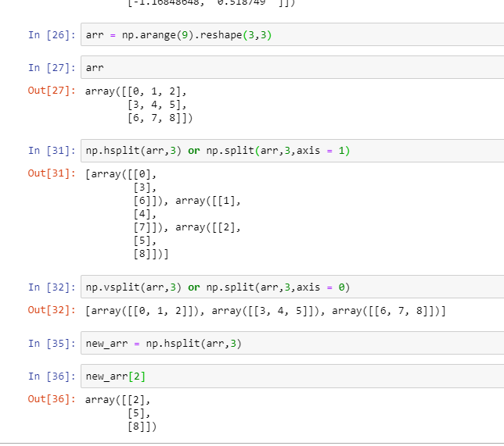

In the above example we see how to use splitting on arrays, there are three methods to split an array i.e. split, vsplit, hsplit

1. split : In split we pass three arguments i.e. array variable , no of splits and the optional axis, at axis = 0 it works like vsplit and at axis = 1 it works like hsplit
2. vsplit : In vsplit we pass two arguments i.e. array variable and no of splits, how it works ? vsplit ek array ko vertically split krta he but kese qn ke jo ke example he usse to lg rha he ke vsplit ne horizontally split kia but in actual wo pura array pick krta he or phir vertically uske row wise hisse krta he means ek row pick ki usko split krdia then again dusri row pick ki split krdia and so on.. but ek cheez ka khyal rkhna he ke array hamesha equally split hoga means ke ye array he 9 values or 3x3 means 3 rows hen or vsplit no of rows ke barabar split kr skta he usse zyada nhi or usse kam sirf tb jb equally split ho rhe hon.

For example :

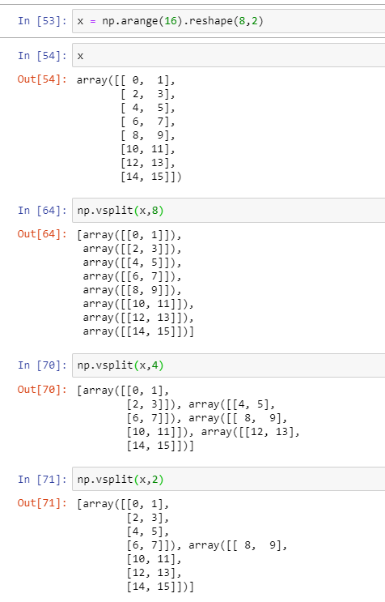

1. hsplit: In hsplit we pass two arguments i.e. array variable and no of splits, how it works ? it works oppositely as compared to vsplit. Hsplit poora array pick krta he or usko horizontally column wise split krta he. Jesa ke pehli example me dekha humne ke arr 3x3 ka array tha means 3 column the to ab hsplit bari bari ek column pick krega or split krdega agar mene no of split 3 diye hen to. Baki sab theory same as vsplit he :-P

no of columns ke barabar split kr skta he or usse less no of split ke liye splits equal hona zaroori hen

for example :

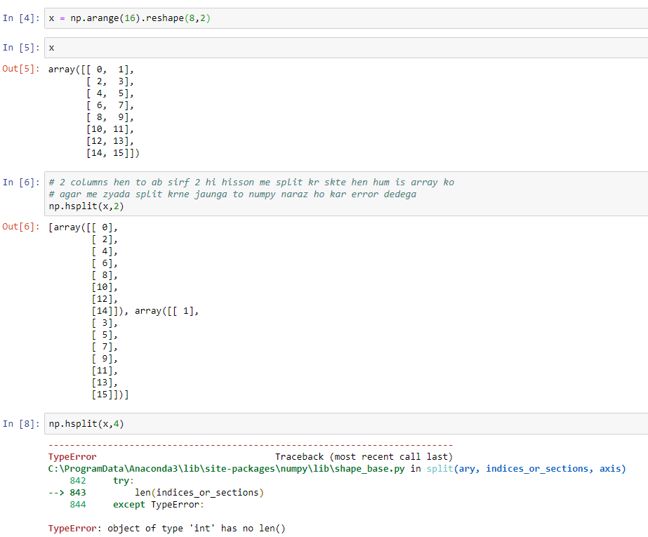

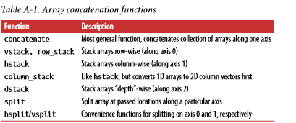

**Repeating Elements: tile and repeat :**